**Project description**

B181905 (Vadla Nagaraju)

B181891 (Gaini Praveen)

B181782 (Tharun)

Class ABII-305 [CSE]

[Note:Our Project .c file purely executable in windows 10]

**Description** :

-> Our project is on offline database that will store data of students in offline files

In means of our data we store student name,student id,student date of birth,student four subjects marks and based on there marks it automatically store the grade by taking average of marks.

By executing our project it will ask to :

1 Login

2 Create account

3 Forgot password

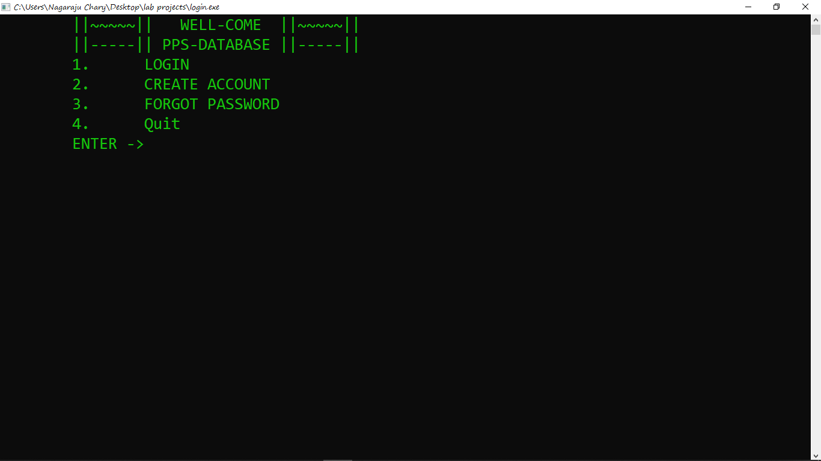

**1 Login:**

-> Asks for an id and password if id and password matches with database it will redirect to that particular page example if admin logins it redirects to admin’s page and if students logins it will redirect to student page and if id or password was wrong it shows incorrect id or password and returns to main page

**2 Create account:**

-> It asks for id and password and a security key (useful in Forgot password)

it will help all the students to create account of login id and password and if account already exists it replies your account already exist if you forgot password click forgot password and update your password

**3 Forgot password**

-> Will help students if they forgot their password and can change their password by a security key they entered

**Admin login :**

-> For read and write purpose we included an admin that he can view data and manipulate the data and inbuit id for admin is 12345 and password is 'admin'

He can login using his id and pass

-> when admin log in we provided 7 options to him

1 Manual Enter, Update and Delete record

2 View All records

3 Allot ranks

4 Notice

5 View Applications

6 Chat box

7 log out

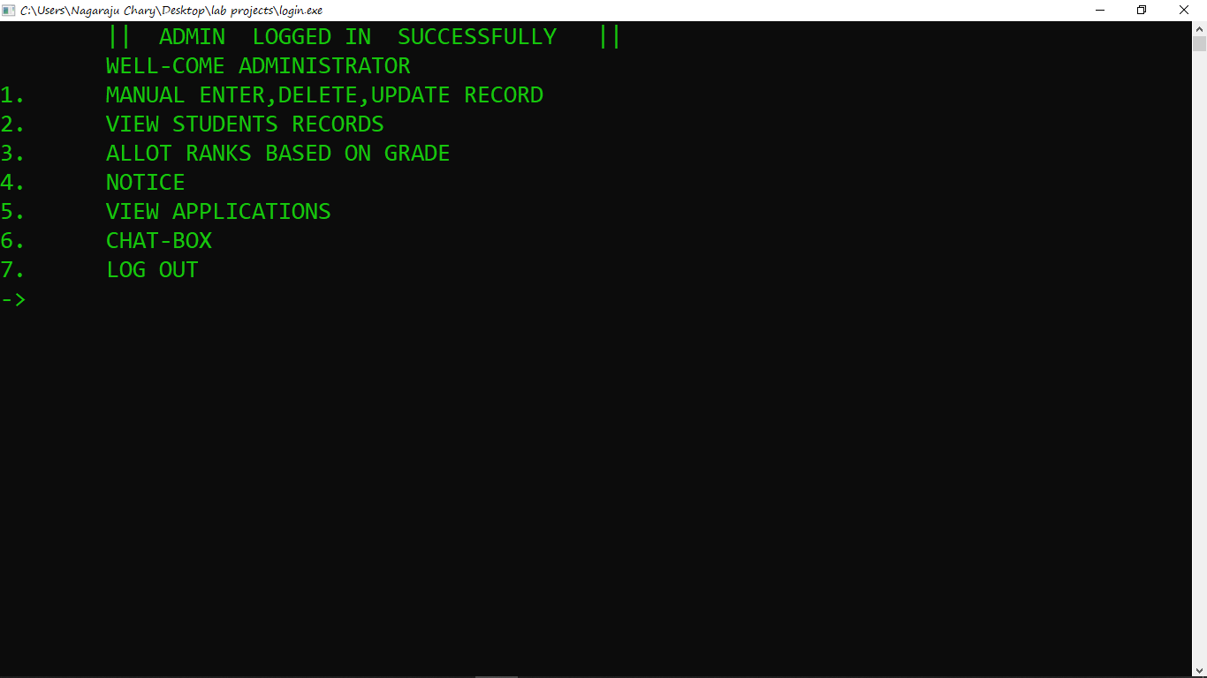

**1st option**

**1 Manual Enter, Update and Delete record**

-> This will help admin to manually enter data or update data or delete data

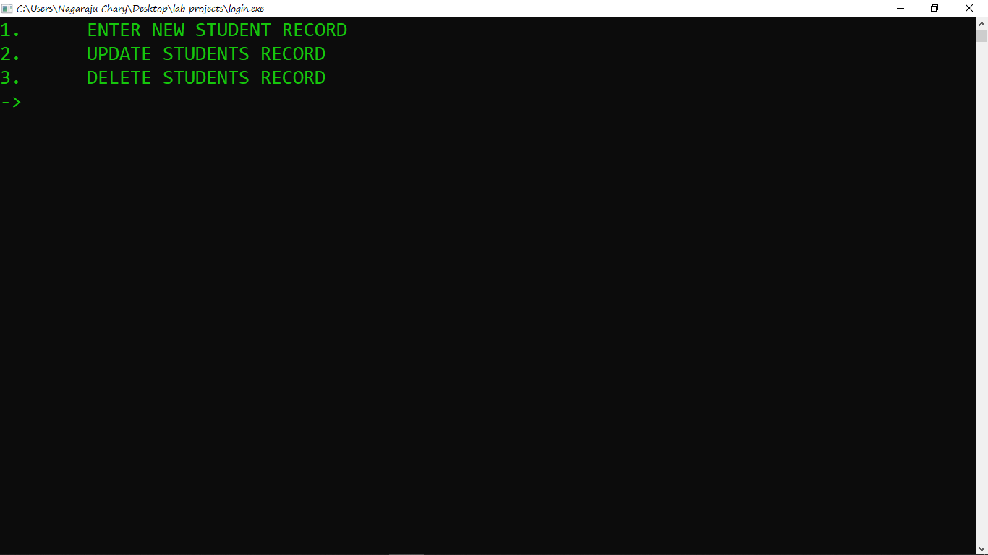

**2nd option**

**2 View All records**

-> Will show all the records in the main database

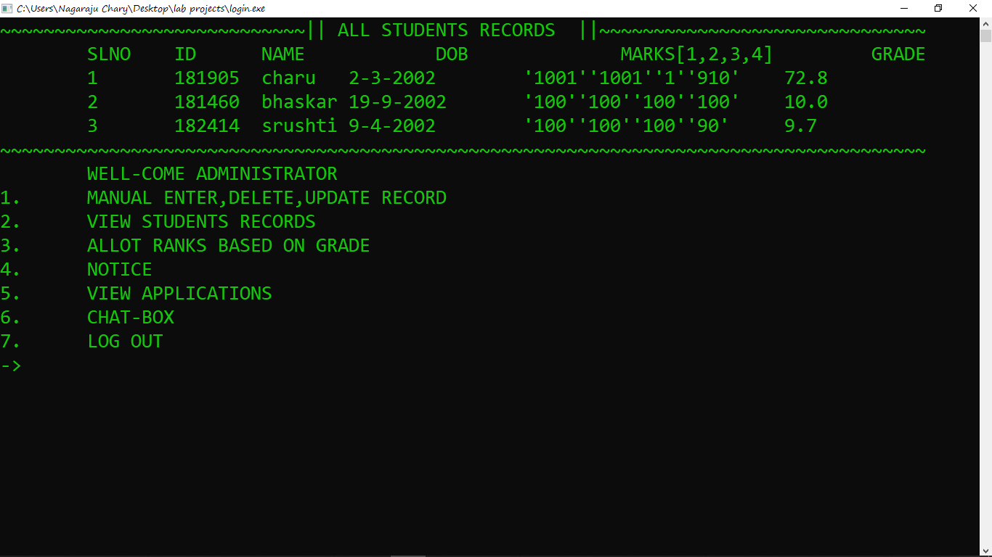

**3rd option**

**3 Allot ranks**

-> Will perform sorting operation based on grade

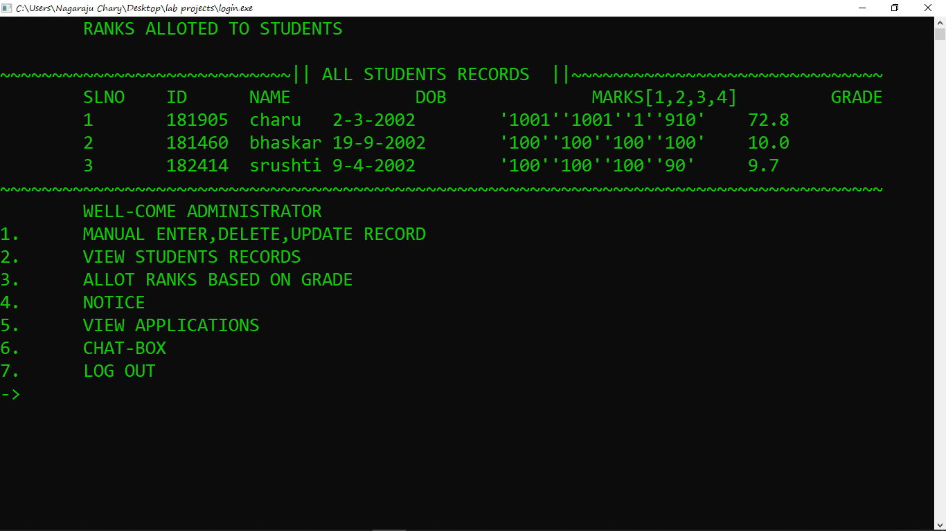

**4th option**

**4 Notice** :

-> Will ask to type your notice, admin write his notice and enter it replies notice updated successfully

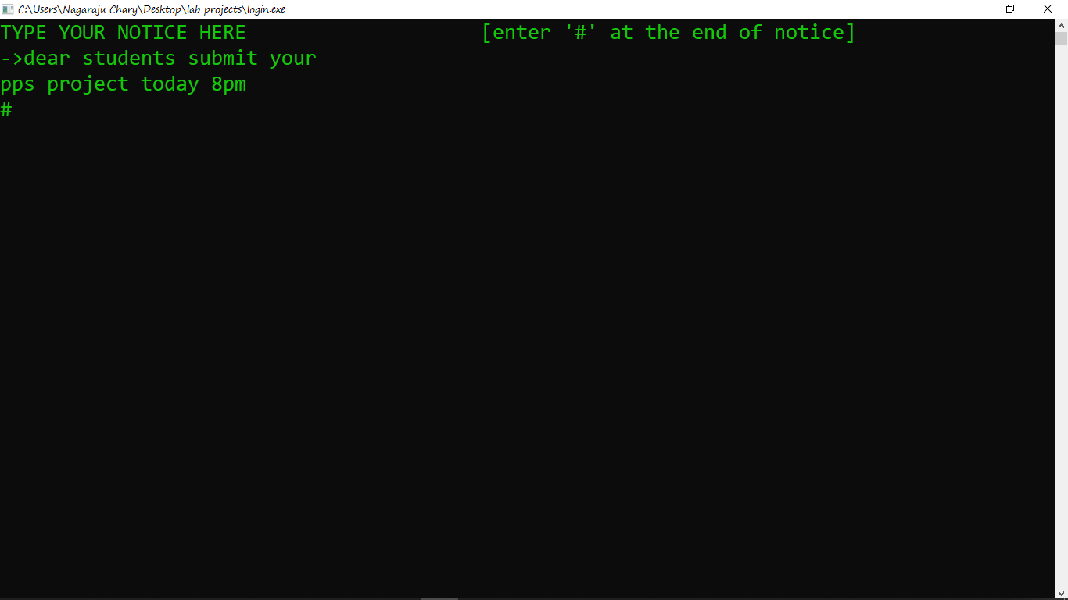

**5th option**

**View Applications**

-> Will show the application list of students who had applied for insertion into main database

And admin have the choice to accept the application and also reject the application. When Admin accept the application that application automatically inserted into main database if admi reject the application will not inserted into main database

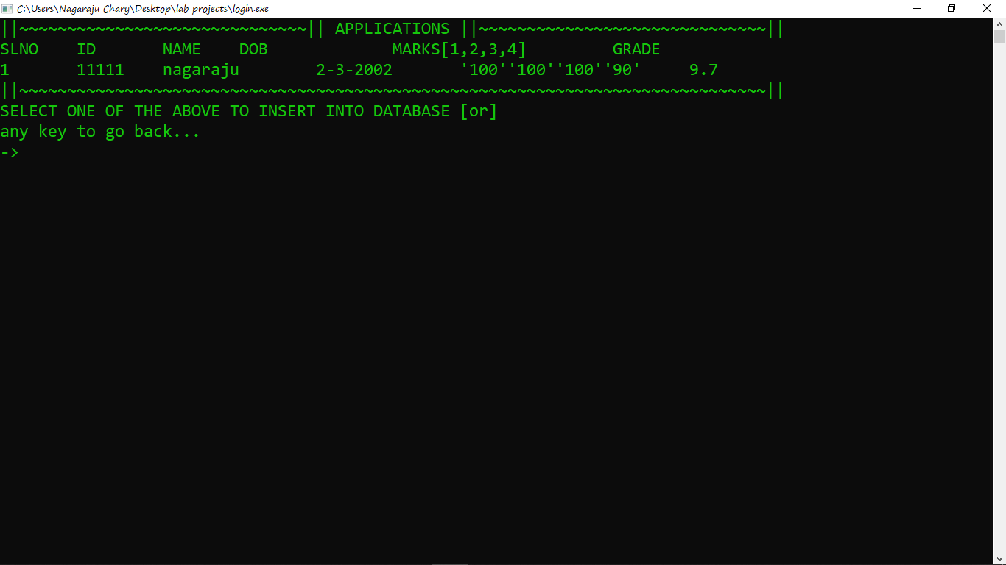

**6th option**

**Chat box**

->Will works as mod3rn whatsapp that will show last 10 chats and admin can chat with all students

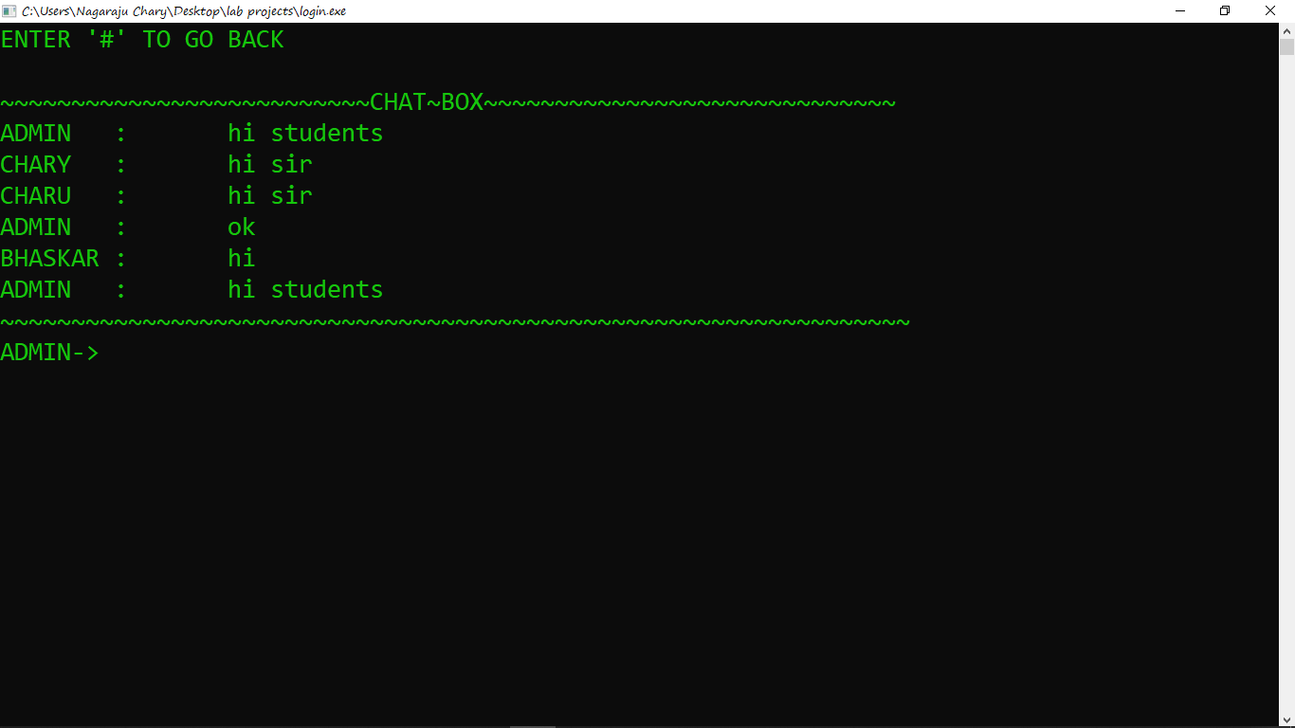

**7th option**

**Log out**

->Will log out the admin login and return to main page

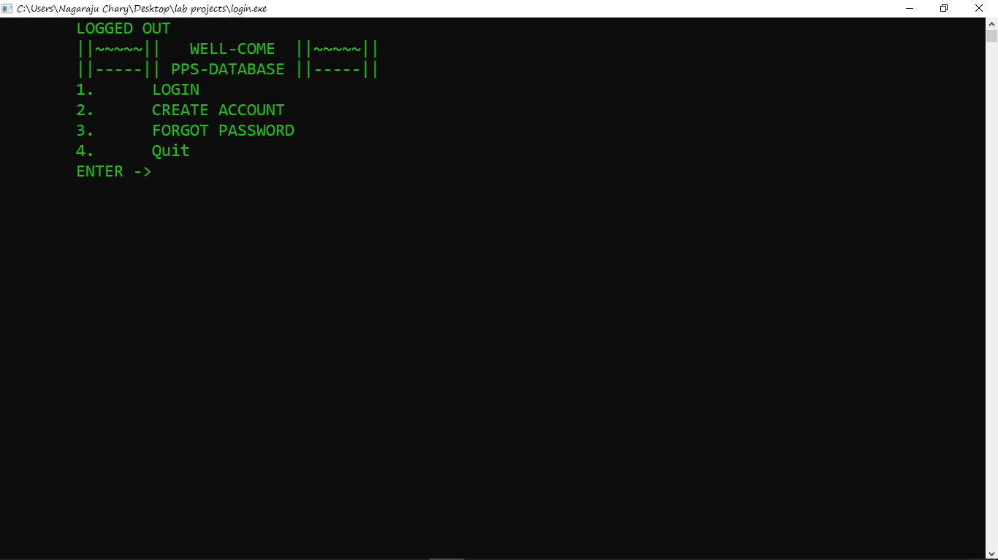

**Student login** :

-> When student login with there id and password if there data is alr2ady there in database it shows( WELL COME NAME), or if they don't have account they will create account if they forgot password they go for forgot password and can login

-> when student logs in first time it will show that there is no data found of yours please apply for new

And student have 7 options

1 View your details

2 View your rank

3 Notice

4 Apply New

5 Apply Modification

6 Chat box

7 Log out

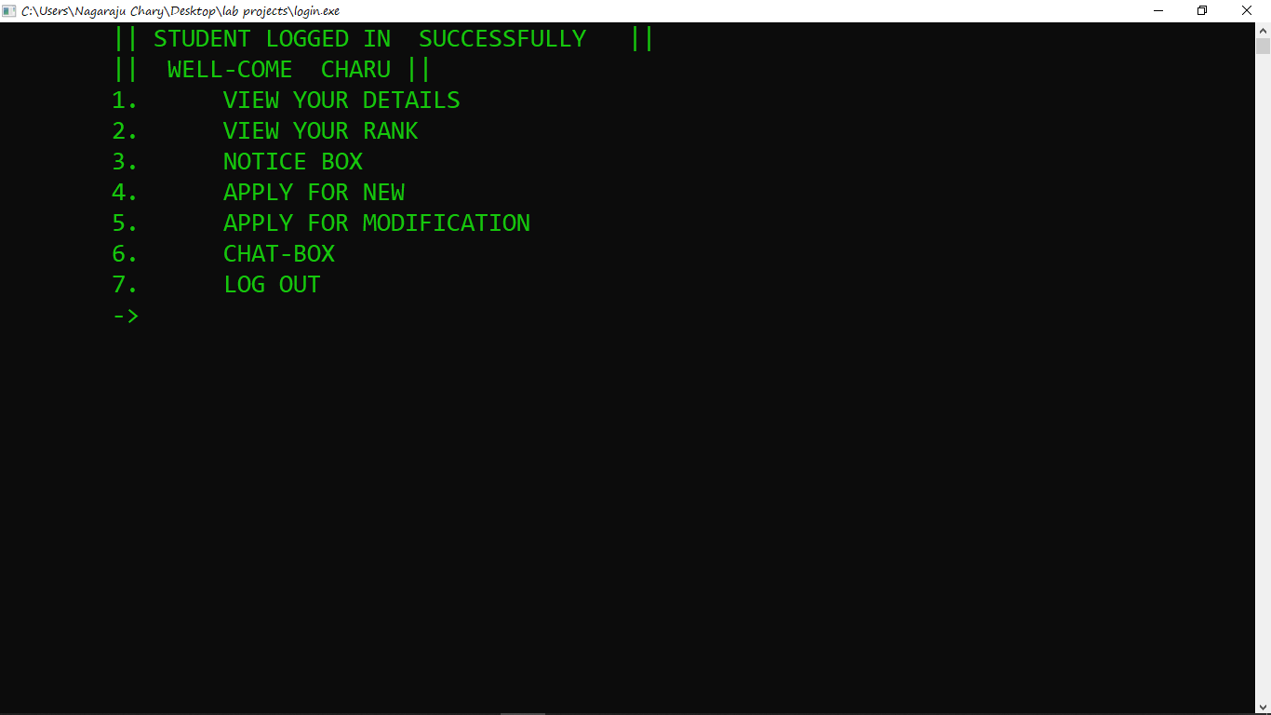

**1st option**

**View your details**

-> If the student data exists it will show his details otherwise it replies your details are not yet entered

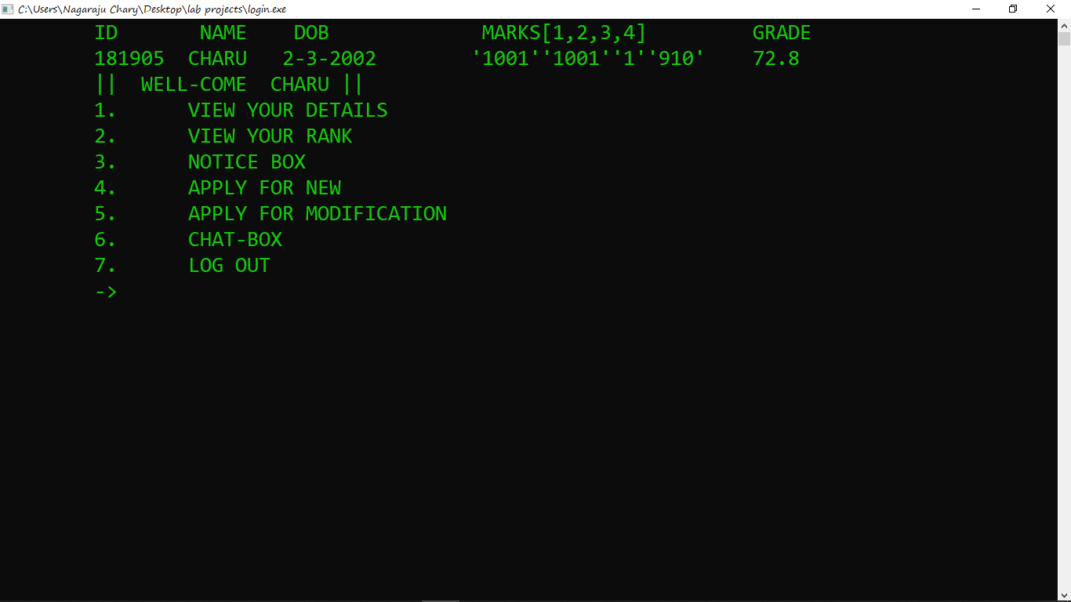

**2nd option**

**View your rank**

-> If the students exits it show the( i+1)th value in our database it will sure that us the rank of the student

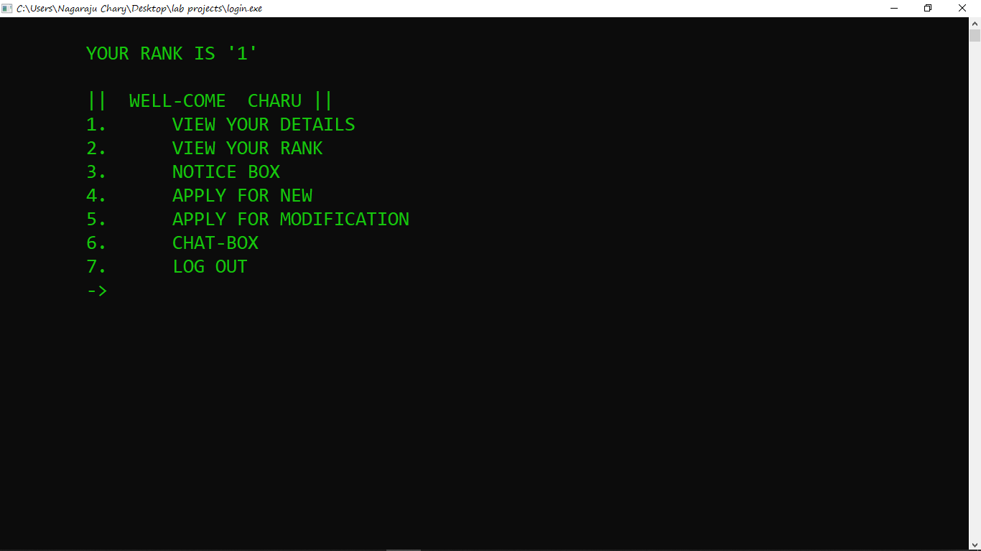

**3rd option**

**Notice**

-> Will show the notice which is created by admin

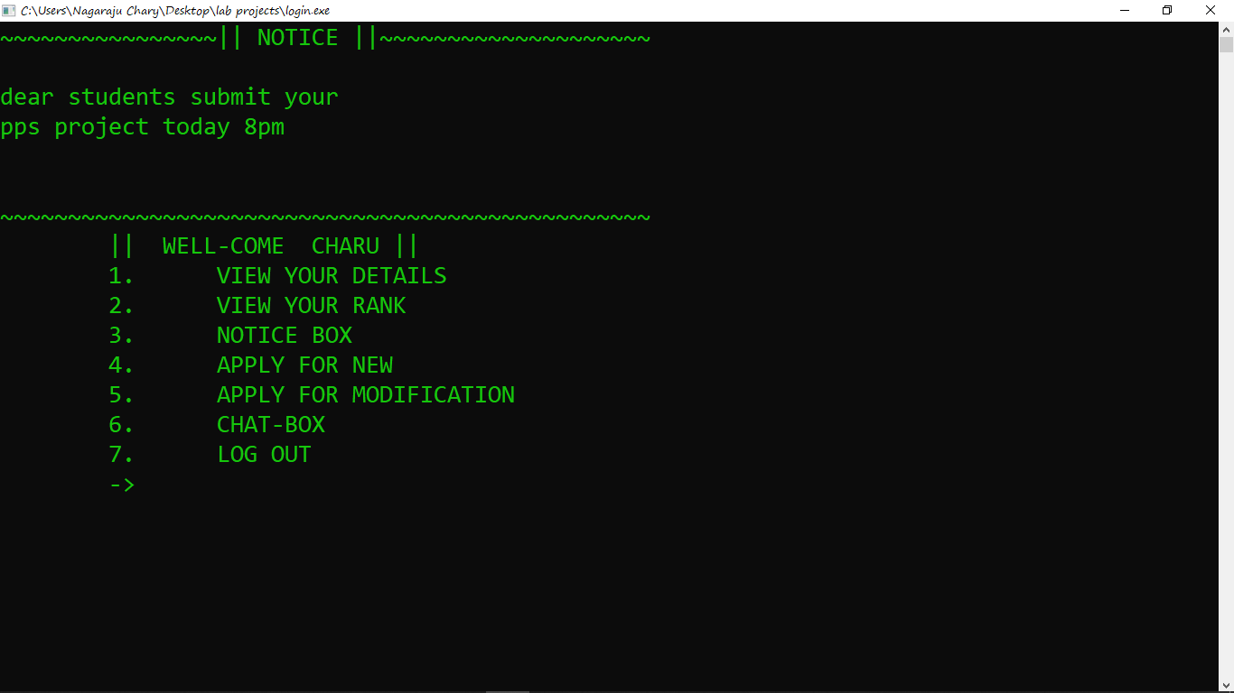

**4th option**

**Apply new**

-> Will ask for some details like name, date if birth, and four subjects marks and returns applied successfully if all are clear

Otherwise if data already there in our database it will replies that your data already there in our database if you want ti change go for Apply modification

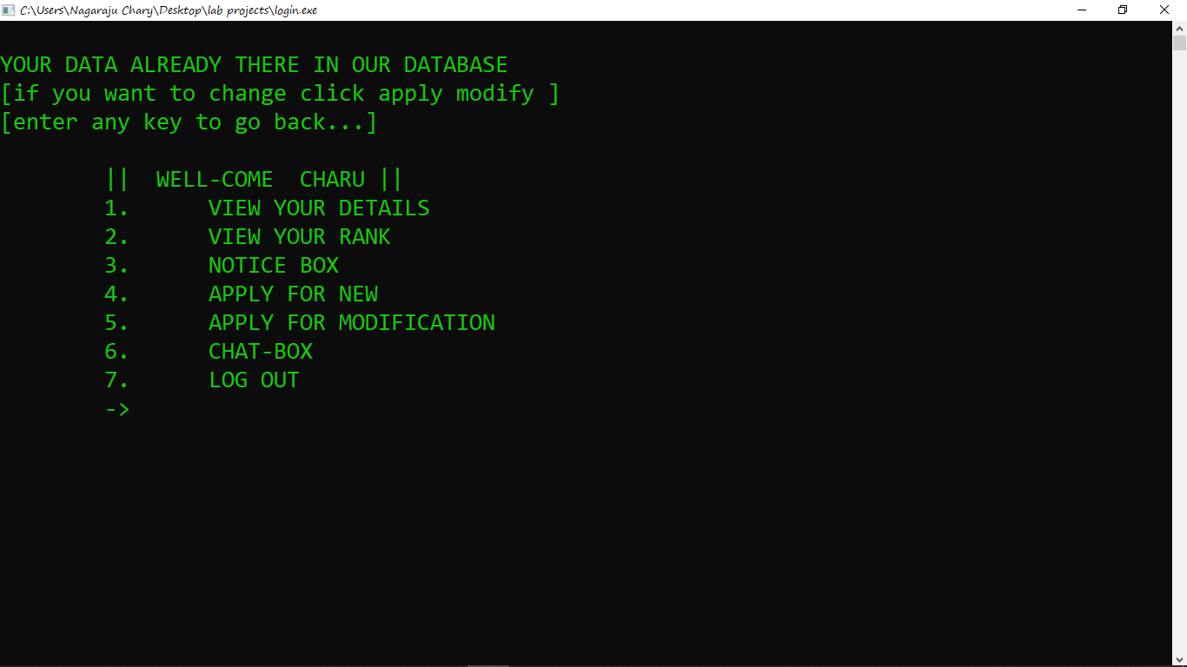

**5th option**

**Apply Modification**

-> Will shows if student already applied it says you are already applied for modification if you want to re-apply cluck cancel and re apply

And we provided a cancel option for that

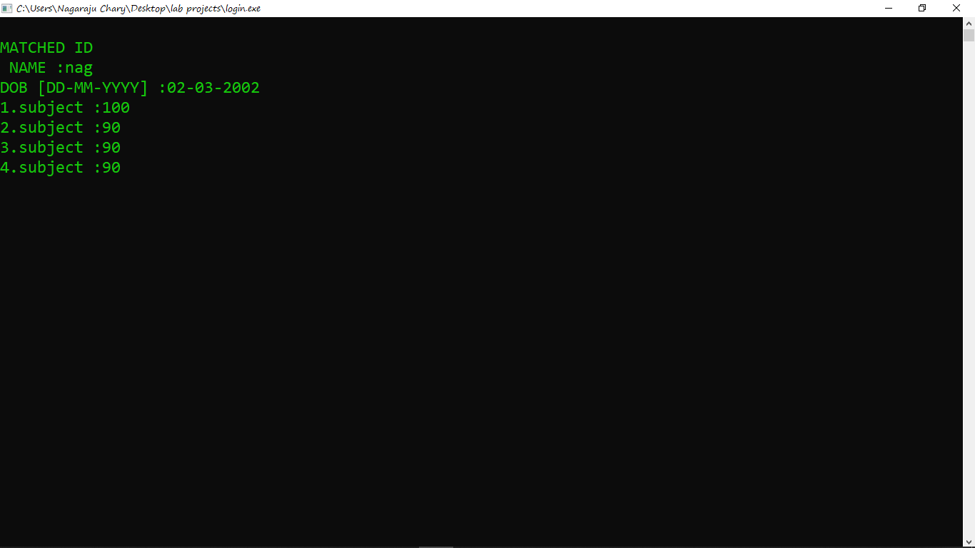

**7th option**

**Log out**

-> Will logs out the students and returns to main page



**Project creators**

B181905(Vadla Nagaraju)

B181891(Gaini Praveen)

B181782(Tharun)

* **Thank you\***